In the first task we performed sampling of analogue signals. The input voltage source, the function generator, was adjusted to output a sine wave with total of 5Vpp (from -2.5V to 2.5V) at 1kHz frequency. The signal was inputted to the E1 input of a Sample & Hold block. The sampling frequency (Fs) was set to 8kHz. The input, output and sampling signals were observed on the oscilloscope.

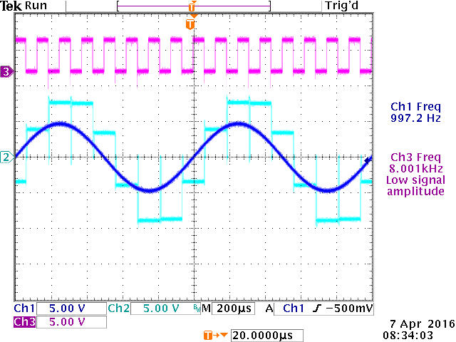

Fig. 1. Uin = 5Vpp, f = 1kHz, Fs = 8kHz

After that the pulse width setting **τ** on the S&H block was varied. As we can see from the following oscilloscope screenshots (Fig 2.1 to Fig 2.5) with increasing the pulse width the bit power increases and the maximum bit rate decreases.

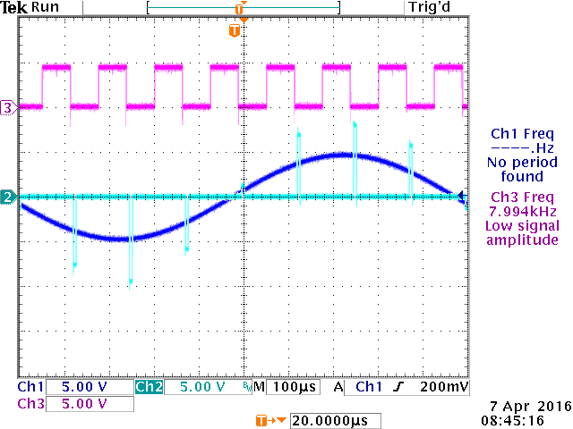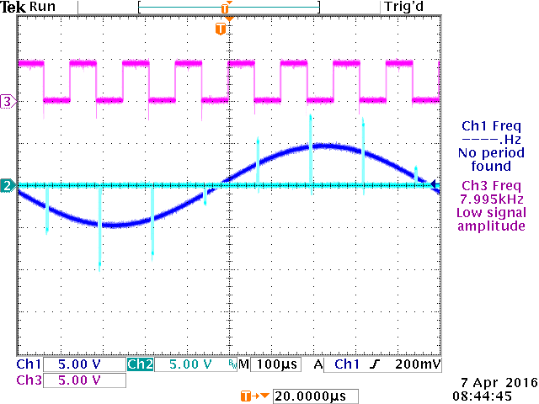  
Fig 2.1. τ = 3µs Fig 2.2. τ = 6µs

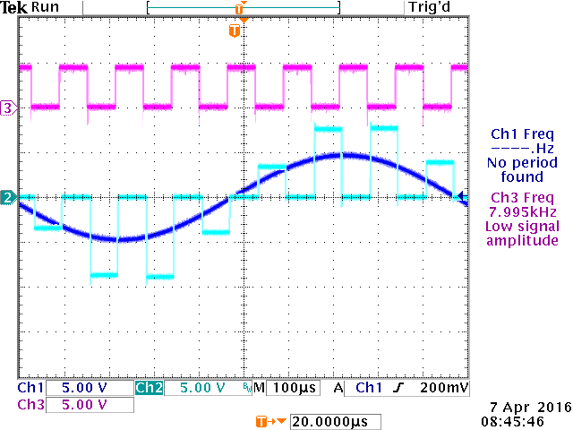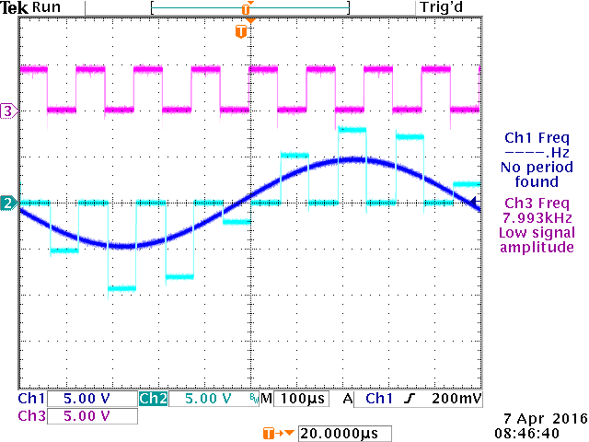

Fig 2.3. τ = 30µs Fig 2.4. τ = 60µs

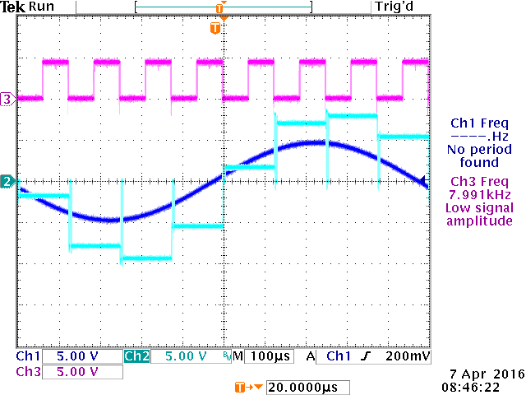

Fig 2.5. τ = 120µs